1 . Output variable -> y
y -> Whether the client has subscribed a term deposit or not
Binomial ("yes" or "no")

Solution:
Business Problem: To predict whether the client has subscribed a term deposit or not
Datasets:
Independent Variable(x):
x1: age
x2: job
x3: marital
x4:education
x5:default
x6:balance
x7:housing
x8:loan
x9:contact
x10:day
x11:month
x12:duration
x13:campaign
x14:pdays
x15:previous
x16: poutcome

Dependent Variable(y): y
EDA :
1.) Initailly summary and structure of the entire datasets is analysed .
The output variable “y”has two class namely, “Yes” and “No”
Input variables:- “age”, “balance” , “day”,”duration”,”campaign”,”pdays”,”prevoius” are numerical variables
The categorical variables are : “job”,”maritial”,”education”,”default”,” housing”,”loan”,”contact”,”month”,”poutcome”
. The above numerical variables are in dtype(int64) and categorical variables are in dtype(object), so any further conversion is not required.
2.) Analysis of missing values
There is no missing values in the datasets for any of the variables.

3.) Graphical Representations
For categorical data
a.) Job
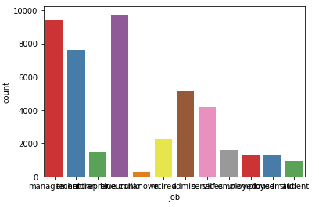
b.) Marital
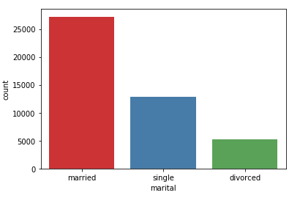
c.) Education
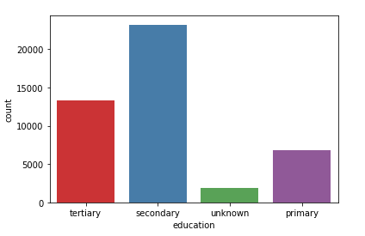
d.) Default
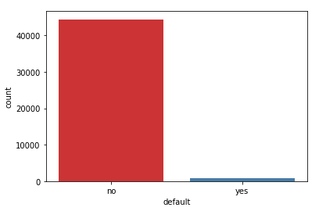
e.) Housing
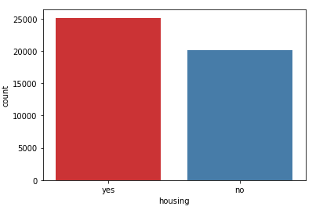
f.) Loan
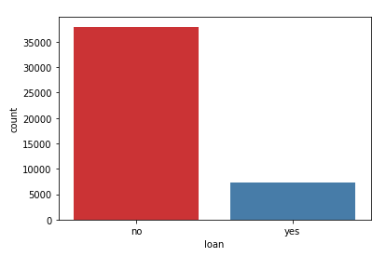
g.) Contact
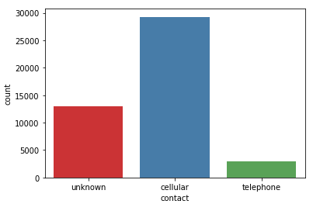
h.) Month
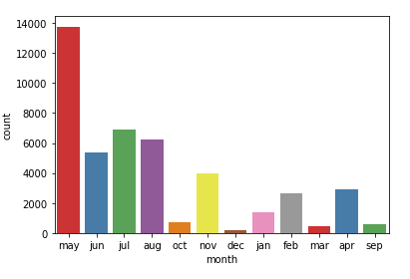

g.) Poutcome
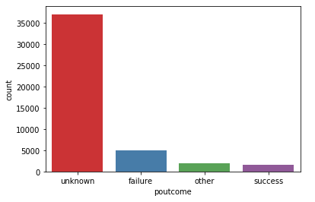
h.) Y
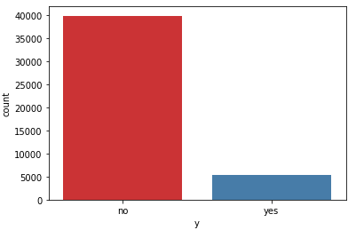

Pair plots of numerical data
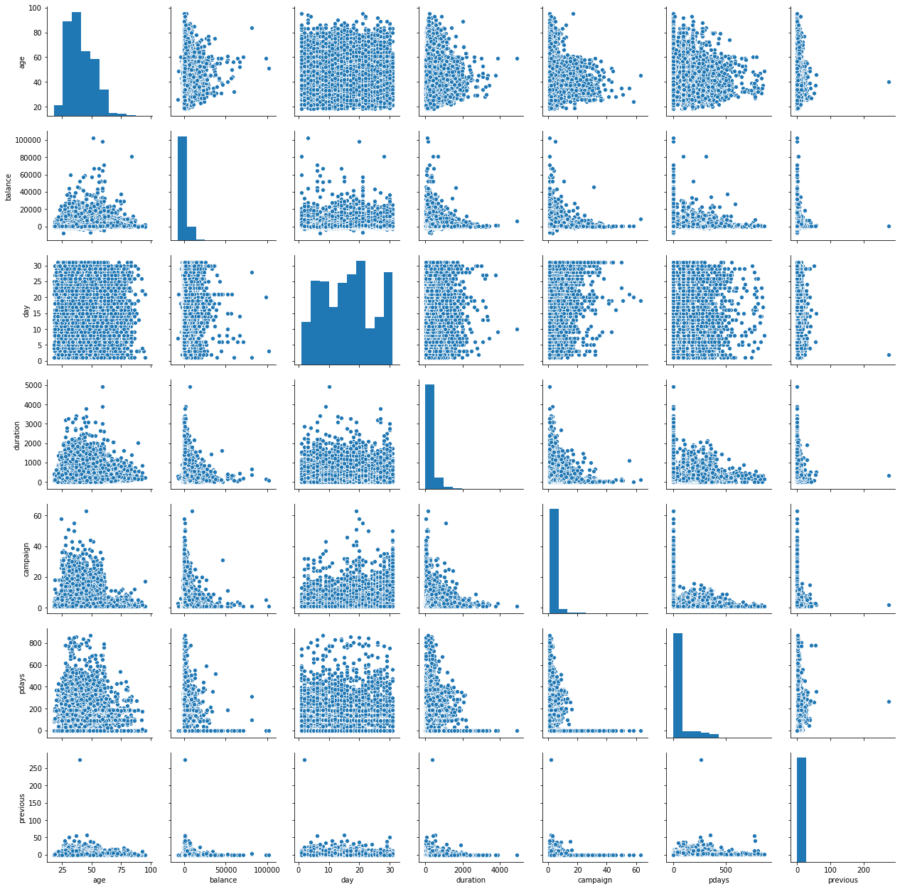

4.) Co-relation
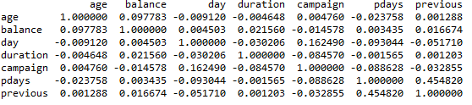
The co-relation coefficient value is poor among the variables
5.) Create dummies
Dummy variables are created for all the input categorical variables
“job”,”maritial”,”education”,”default”,” housing”,”loan”,”contact”,”month”,”poutcome”
6.) Changing response variable “y” into binary format
Replaced “Yes” with 1 and “No” with 0
5.) Data Partitioning
Dividing the datasets into train and test data set
Training datasets = 70% of the bank_data
Train datasets = Remaining 30 % of the bank_data
Model Building
Model Summary
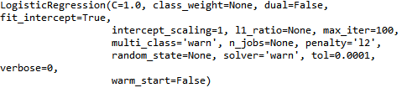

Coefficients
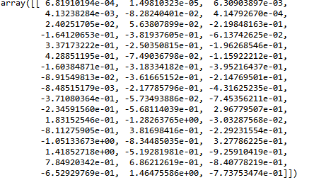
Predicting variables : Passing the testdata in predict function w.r.t. model , we get predicted values.
Confusion Matrix

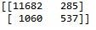

Accuracy = 0.9008 =90%
Error = 1-0.9008 =9.9%

AUC score = 0.65621
ROC curve
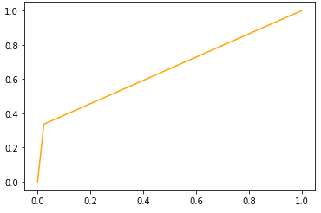

2.) Classify whether application accepted or not using Logistic regression
Card Factor: Was the application for a credit card accepted?
Reports : Number of major derogatory reports.
Age : Age in years plus twelfths of a year.
Income :Yearly income (in USD 10,000).
Share : Ratio of monthly credit card expenditure to yearly income.
Expenditure : Average monthly credit card expenditure.
Owner : Factor. Does the individual own their home?
Selfemp : Factor. Is the individual self-employed?
Dependents :Number of dependents.
Months: Months living at current address.
Majorcards : Number of major credit cards held.
Active :Number of active credit accounts.

Solution:
Business Problem: To check if the application for a credit card accepted or not.
Datasets:
Independent Variables:
x1: reports
x2: age
x3: income
x4 : share
x5 : expenditure
x6 : owner
x7: selfemp
x8 :dependents
x9 :months
x10: majorcards
x11: active
Dependent Variable (y): card (discrete)
EDA :
1.) Initailly summary and structure of the entire datasets is analysed .
The output variable “card”has two class namely, “Yes” and “No”
Input variables:- “reports”, “age” , “income”, ”share”, ”expenditure”, ”dependents”, ”months”, “majorcards”,”active”are numerical variables
The categorical variables are : “owner”,”selfemp”.
The above numerical variables are in type(integer) or (float)and categorical variables are in type(object), so any further conversion is not required.
2.) Analysis of missing values
There is no missing values in the datasets for any of the variables.

3.) Pair plots of numerical data
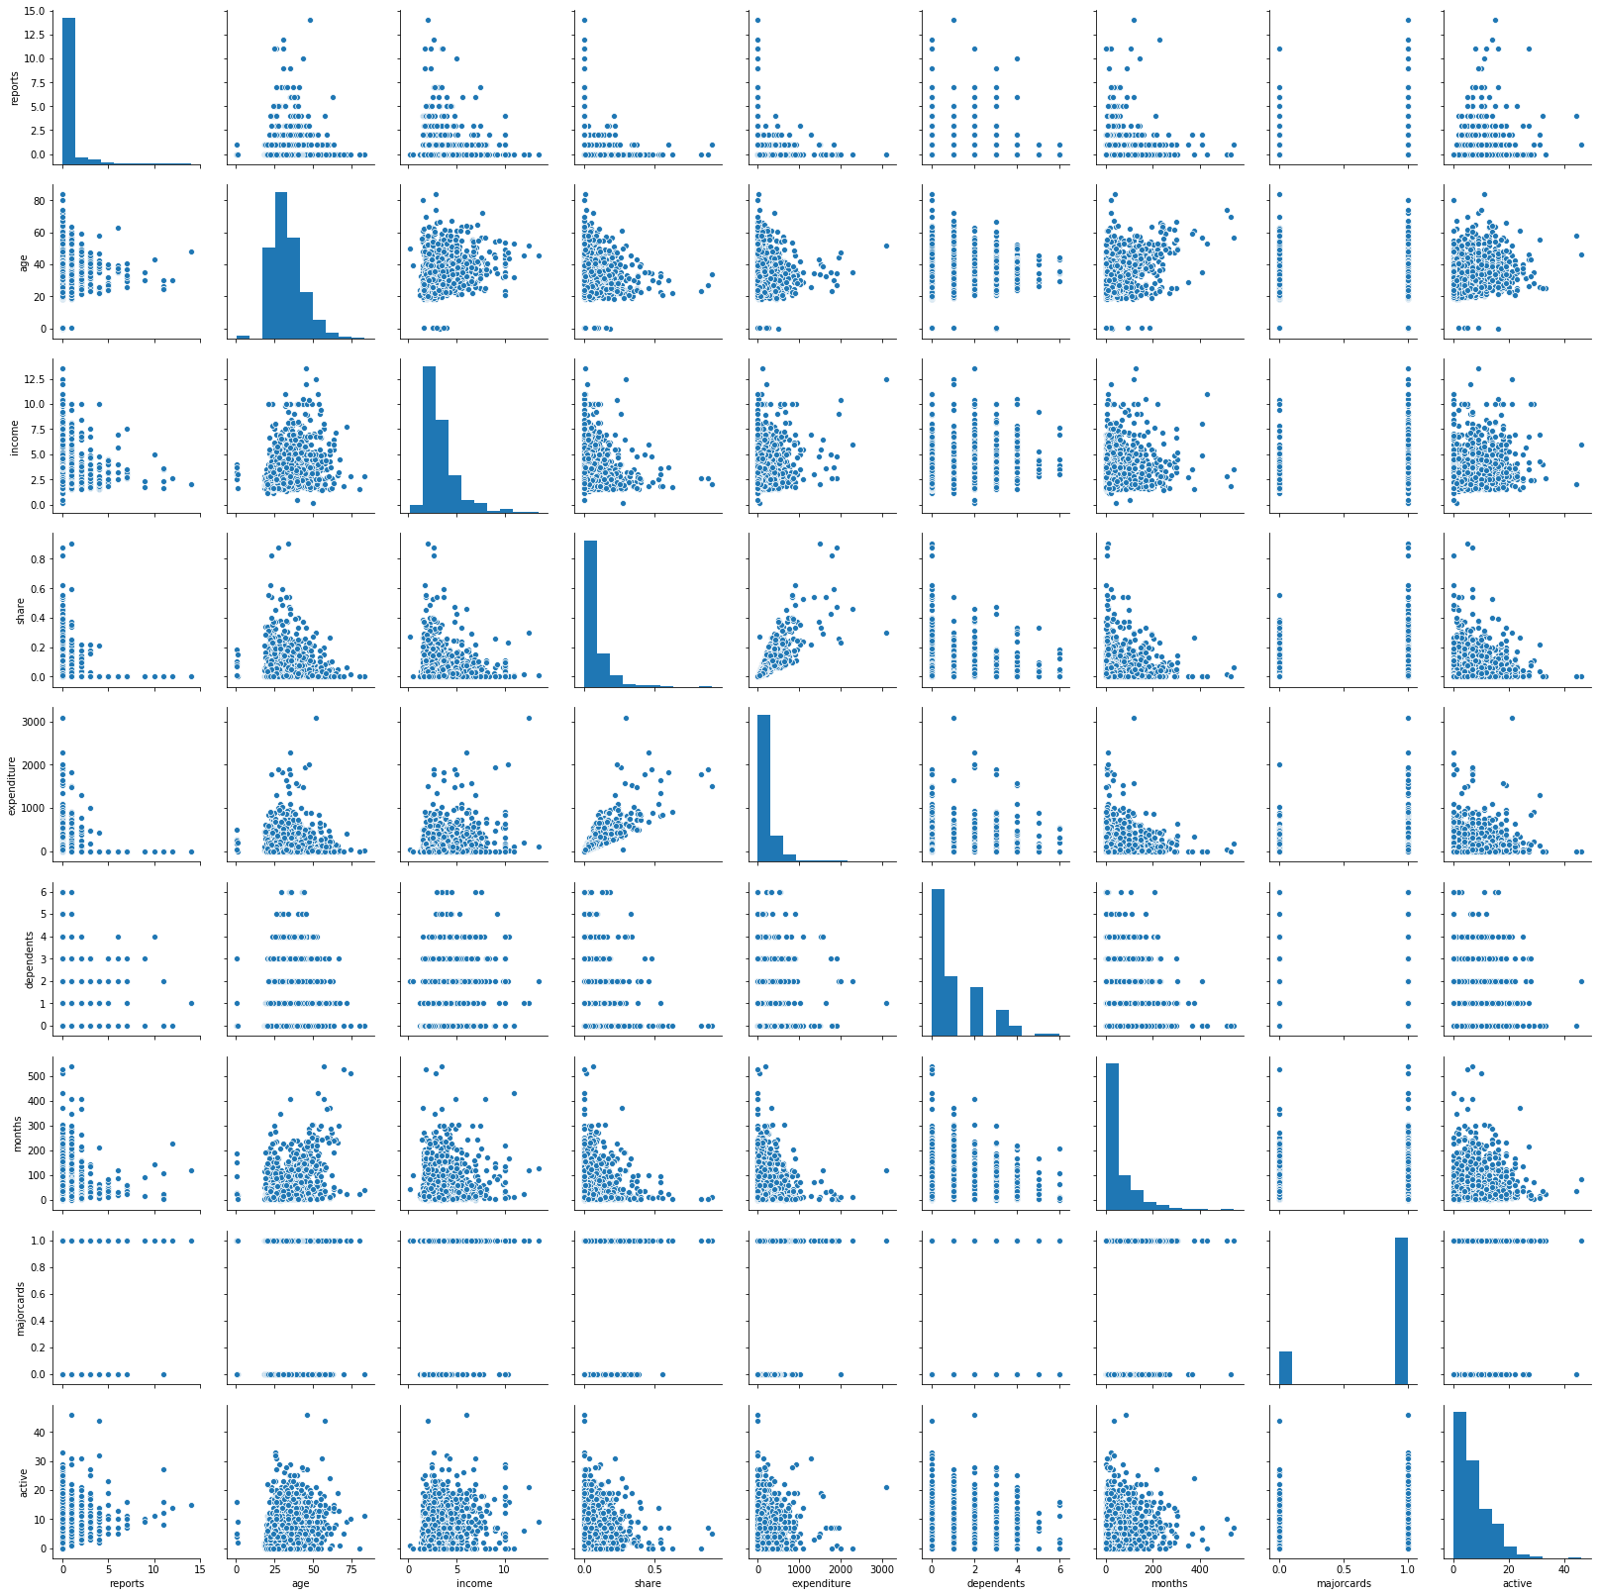
4.) Co-relation
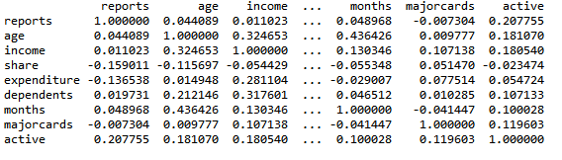

From the above variable, we could say that there is no strong co-relation among the variables.
5.) Changing response variable into binary format
Replaced “Yes” with 1 and “No” with 0
6.) Data Partitioning
Dividing the datasets into train and test data set
Training datasets = 70% of the credit data
Train datasets = Remaining 30 % of the credit data
Model Building
Model Summary
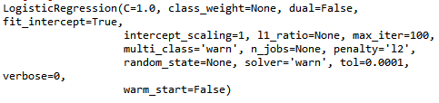

Coefficients
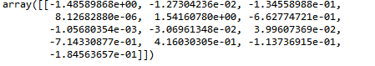

Predicting variables: Passing the testdata in predict function w.r.t. model , we get predicted values.
Confusion Matrix
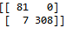

Accuracy = 0.9823 or 98.23%
Error = 1-0.9823= 1.76 = 0.6 or 6%

AOC score =0.98

ROC curve

